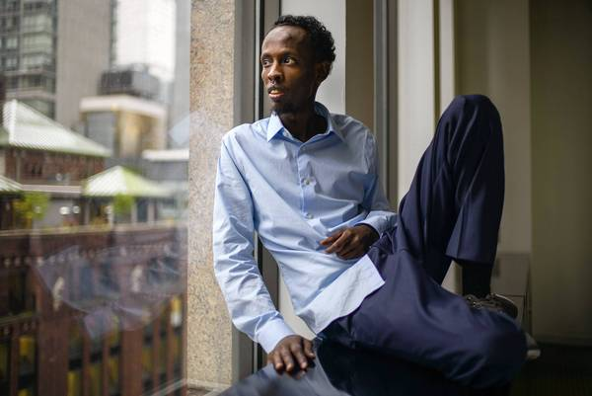 

latimes.com/entertainment/movies/moviesnow/la-et-mn-somali-actor-20131014,0,643861.story

**Somali actor Barkhad Abdi makes most of his chance in 'Captain Phillips'**

**Emigré Barkhad Abdi, 27, has received good notices for his improbable screen debut as a ruthless pirate opposite Tom Hanks in 'Captain Phillips.'**

By Rebecca Keegan

6:00 AM PDT, October 14, 2013

Barkhad Abdi is used to finding his way in strange new places: At age 7, he moved with his family from war-torn Somalia to Yemen, where he learned Arabic on the soccer field. At 14, he moved to Minneapolis and learned English from Jay-Z songs and "Seinfeld" episodes.

Now, at 27, Abdi has made himself at home in another new town — Hollywood — by starring opposite Tom Hanks in the film "Captain Phillips." In director Paul Greengrass' fact-based thriller, which opened Friday, Abdi plays Muse, a Somali pirate who hijacks an American cargo ship and takes its captain hostage.

When Greengrass cast him, Abdi was driving a limo in Minneapolis; now his face is ubiquitous on billboards and in TV commercials, and he has appeared on the "Today" show and CNN.

**[PHOTOS: Captain Phillips on screen and in real life](http://www.latimes.com/entertainment/movies/moviesnow/la-et-mn-captain-phillips-photos-20131010,0,6001438.photogallery" \t "_blank)**

"My Facebook is just going bananas," Abdi said, breaking into a toothy grin during a rest between two recent screenings of the film on the Sony Pictures lot in Culver City. "People all over are telling me they're proud of me. Someone said to me, 'You put Somalia back on the map.'"

The tale of Abdi's life is as improbable as any Hollywood movie. The son of a teacher in Mogadishu, Abdi was on the verge of starting elementary school when the Somali civil war broke out in 1991.

"Everything changed," said Abdi, who is one of four children. "At night, me and my brother would sleep to the gunshots. We would name the guns. And there was this lady that would be raped, very loud.... You would hear that lady every night, 'Someone help me,' she's screaming."

Abdi's family fled to Yemen during the night when he was 7, and though they left the violence of Somalia behind, they also left the comforts of their community.

"Mostly black kids don't go to school in Yemen," Abdi said. "They're poor people there. In Somalia, everybody was my family, neighbors.... Now all of a sudden I'm an outsider."

When he was 14, Abdi's family won a U.S. greencard lottery and moved to Minneapolis, where a Somali immigrant community was growing rapidly. Today, more than 14,000 Somalis live in the city, but transition to the American Midwest was a challenge.

"It's just human nature that people don't like something different," Abdi said. "When the Somali people started coming to Minneapolis, some of the African American community saw them as a threat. But most Somali kids, we don't fight. So when people would start, we just...." Abdi shrugged.

After high school, Abdi worked at Target. He was working as a chauffeur when he saw a report on the local news that a casting director for a Tom Hanks movie was coming to Minneapolis looking for Somali actors. Abdi was familiar with the story of the hijacking, which he had followed in news reports when it happened in 2009.

"Some Somali people were saying this movie would embarrass the Somali people," Abdi said. "Before I went to the casting, there was that kind of talk. But to me it was an opportunity. I had to try it and give it a chance."

At the audition, Abdi ran into friends — Faysal Ahmed, Mahat M. Ali and Barkhad Abdirahman — and they decided to rehearse together. The foursome worked for a week on a key scene where the pirates first storm the bridge of the cargo ship. After making it through multiple callbacks in Minneapolis, they traveled to Los Angeles to meet with casting director Francine Maisler and Greengrass.

"Barkhad just had a great charisma and a sense of menace," Greengrass said. "But also something sort of different, some sort of humanity in there too. You feel him in all his violence but also his desperation, and that's good."

Abdi and his friends also had a physical attribute that would have been difficult for many American-born actors to match — their incredible leanness. He is 5-foot-10 and 120 pounds. "I'm naturally like this," Abdi said. "I eat whatever. Burgers, pasta, rice."

Cast as a group, the four young men journeyed to the set in Malta to learn how to handle the boats and guns they would be using in the film. Abdi, who didn't know how to swim, learned to balance on an unstable pirate skiff in choppy waters and to climb a ladder up a swaying cargo ship.

Greengrass deliberately kept the Somali actors apart from Hanks to improve their performances, he said.

"I didn't want them to be intimidated by him, and I didn't want them to be nice to him," Greengrass said. "I wanted them to be absolutely ruthlessly committed to what they were doing, which is an armed takeover of a container ship."

Abdi, who had grown up watching Hanks' movies, suffered his first bout of nerves the night before they were to shoot the storming-of-the-bridge scene.

"We were all excited to see Tom," Abdi said. "Then I realized the weight of it. I couldn't sleep much that night thinking about it.... I said to myself, 'OK, it all comes down to this. I'm the captain now.' After we shot I thought, 'I can't believe I'm doing a scene with the 'Forrest Gump' guy.'"

A Greengrass movie may be an ideal set for a first-time actor. The director of such films as "United 93" and "The Bourne Ultimatum" relies on techniques he learned in the unrehearsed world of documentaries. Actors don't have to hit marks in Greengrass movies — cameras follow the performers, and natural-sounding dialogue is encouraged over perfect line readings.

"Barkhad's timing was almost antithetical to the pretend aspect of making a movie," Hanks said. "He took his own timing. He didn't say his line right on the cue. There was no such thing as a cue. It was as grand and extraordinary and as natural as anything I've ever done in films before."

Abdi said he related to his character's struggle in the film — though Muse's path was one of violence, he was trying to improve his lot in life.

"My parents took me out of there, but what if they didn't?" Abdi said. "I would be stuck in Somalia. I'm sure I wouldn't be the same person. I see the desperation of this guy. He must do a lot of stuff to get that one chance, and once he's got that chance, he can't give it up."

Since the movie wrapped, Abdi has traveled to the New York Film Festival and participated in Q&As and other publicity for the film. He has said he would like to get an agent and continue acting.

In the meantime, he's basking in warm comments from film critics, who have praised his intensity, and from Somalis around the world who have seen the film.

"[Barkhad's story] is a most wonderful story about Somalia, but it's also a most wonderful story about America," Greengrass said. "We see so many horrendous things in the world, but there are stories of hope all around."

[*rebecca.keegan@latimes.com*](mailto:rebecca.keegan@latimes.com)

Copyright © 2013, [Los Angeles Times](http://www.latimes.com/)